**UNIT-I**

# INTRODUCTION TO MANAGERIAL ECONOMICS & DEMAND ANALYSIS

# ECONOMICS

Economics is the study of scarcity and its implications for the use of resources, production of goods and services, growth of production and welfare over time. It studies how individuals, businesses, governments, and societies allocate scarce resources to satisfy their needs and wants.

Economics is a study of human activity both at individual and national level. The economists of early age treated economics merely as the science of wealth. The reason for this is clear. Every one of us in involved in efforts aimed at earning money and spending this money to satisfy our wants such as food, Clothing, shelter, and others. Such activities of earning and spending money are called “Economic activities”.

According to **Adam Smith**

“Economics is the study of nature and uses of national wealth”.

According to **Dr. Alfred Marshall**

“Economics is a study of man’s actions in the ordinary business of life: it enquires how he gets his income and how he uses it”.

# MICRO AND MACRO ECONOMICS

**MICRO ECONOMICS**

The study of an individual consumer or a firm is called Micro Economics. It is also called the theory of Firm. Micro means one millionth. Micro Economics deals with behavior and problems of single individual and of micro organization. It focuses on how these economic units make decisions about allocating resources and interacting with each other.

# MACRO ECONOMICS

The study of aggregate or total level of economic activity in a country is called Macro Economics. It deals with the total aggregates. It focuses on the behavior of the economy as a whole. For instance, total national income, total employment, total output and total investment. It studies the interrelations among various aggregates and examines their nature and behavior, their determination and causes of their fluctuations in them.

It studies the flow of economic resources or factors of production (such as land, labour, capital, organization and technology) from the resource owner to the business firms and then from the business firms to the households.

# INTRODUCTION TO MANAGERIAL ECONOMICS

Managerial Economics as a subject gained popularity in USA after the publication of book “Managerial Economics” by Joel Dean. Managerial Economics refers to the firm’s decision making process. It could be also interpreted as “Economics of Management”. Joel Dean observes managerial economics shows how economic analysis can be used in formulating policies.

# MANAGERIAL ECONOMICS:

Managerial economics is a branch of economics that uses economic theories and principles to help managers make decisions for a company, which means involving the application of economic methods in the organizational decision-making process. It's also known as business economics.

Managerial economics involves the use of economic theories and principles to make decisions regarding the allocation of scarce resources. It guides managers in making decisions relating to the company's customers, competitors, suppliers, and internal operations.

Managerial Economics is also called as “Industrial Economics” or “Business Economics”.

Managerial Economics refers to the firm’s decision making process. It could be also interpreted as “Economics of Management”. Managerial Economics is also called as “Industrial Economics” or “Business Economics”.

Managerial Economics bridges the gap between traditional economics theory and real business practices in two days. First it provides a number of tools and techniques to enable the manager to become more competent to take decisions in real and practical situations. Secondly it serves as an integrating course to show the interaction between various areas in which the firm operates.

Managerial Economics, therefore, focuses on those tools and techniques, which are useful in decision-making

# DEFINITIONS OF MANAGERIAL ECONOMICS

1. **M.H.SPENCER AND L. SIEGELMAN** Managerial Economics defined as “the integration of economic theory with business practice for the purpose of facilitating decision making and forward planning by management”.
2. **BRIGHAM AND PAPPAS** believe that managerial economics is “The application of economic theory and methodology to business administration practice”.
3. **C.I.SAVAGE AND T.R.SMALL** therefore believes that managerial economics is concerned with business efficiency.
4. **HAGUE** observes that “Managerial Economics is a fundamental academic subject which seeks to understand and to analyze the problems of business decision-making”.
5. In the words of **PAPPAS AND HIRSHEY** “Managerial Economics applies economic theory and methods to business and administrative decision-making. Because it uses the tools and techniques of economic analysis to solve managerial problems, managerial economics links traditional economics with decision sciences to develop important tools for managerial decision-making”.
6. **MICHAEL R.BAYE** defines Managerial Economics as “the study of how to direct scarce resources in a way that most efficiently achieves a managerial goal”.
7. **HAYNES, MOTE AND PAUL** define Managerial Economics as “economics applied in decision-making. They consider this as a bridge between the abstract theory and the managerial practice”.

# NATURE / CHARACTERISTICS OF MANAGERIAL ECONOMICS

* 1. **Close to microeconomics**: Managerial economics is concerned with finding the solutions for different managerial problems of a particular firm. Thus, it is more close to microeconomics.
  2. **Operates against the backdrop of macroeconomics**: The macroeconomics conditions of the economy are also seen as limiting factors for the firm to operate. In other words, the managerial economist has to be aware of the limits set by the macroeconomics conditions such as government industrial policy, inflation and so on.
  3. **Normative statements**: A normative statement usually includes or implies the words

‘ought’ or ‘should’. They reflect peoples moral attitudes and are expressions of what a team of people ought to do. For instance, it deals with statements such as Government of India should open up the economy. Such statements are based on value judgments and express views of what is ‘good’ or ‘bad’, ‘right’ or ‘wrong’. One problem with normative statements is that they cannot to verify by looking at the facts, because they mostly deal with the future. Disagreements about such statements are usually settled by voting on them.

* 1. **Prescriptive actions**: Prescriptive action is goal oriented. Given a problem and the objectives of the firm, it suggests the course of action from the available alternatives for optimal solution. If does not merely mention the concept, it also explains whether the concept can be applied in a given context on not. For instance, the fact that variable costs are marginal costs can be used to judge the feasibility of an export order.
  2. **Applied in nature**: ‘Models’ are built to reflect the real life complex business situations and these models are of immense help to managers for decision-making. The different areas where models are extensively used include inventory control, optimization, project management etc. In managerial economics, we also employ case study methods to conceptualize the problem, identify that alternative and determine the best course of action.
  3. **Offers scope to evaluate each alternative**: Managerial economics provides an opportunity to evaluate each alternative in terms of its costs and revenue. The managerial economist can decide which is the better alternative to maximize the profits for the firm.
  4. **Interdisciplinary**: The contents, tools and techniques of managerial economics are drawn from different subjects such as economics, management, mathematics, statistics, accountancy, psychology, organizational behavior, sociology and etc.
  5. **Assumptions and limitations**: Every concept and theory of managerial economics is based on certain assumption and as such their validity is not universal. Where there is change in assumptions, the theory may not hold good at all.

# SCOPE OF MANAGERIAL ECONOMICS

The main focus in managerial economics is to find an optimal solution to a given managerial problem, the problem may related to production, reduction or control of cost, determination of price of a given product or service, make or decisions, inventory decisions, capital management or profit planning and management, investment decisions or human resource management. While all these are the problems, the managerial economics makes use of the concepts, tools and techniques of economics and other related discipline to find an optimal solution to a given managerial problem.

# Demand Decision:

The analysis and forecasting of demand for a given product and service is the first task of the managerial economist.

The behavioral implications such as the needs of the customers’ responses to a given change in the price or supply are analyzed in a scientific manner.

The impact of changes in prices, income levels and prices of alternative products / services are assessed and accordingly the decisions are taken to maximize the profits.

Demand at different price levels at different points of time ias forecast to plan the supply accordingly and initiate changes in price, if necessary, to enlarge the customer base and gain more profits.

Determination elasticity of demand and demand forecasting constitute the strategic issues that the managerial economist handles in a scientific way.

# Input-Output Decision:

Here, the costs of inputs in relation to output are studied to optimise the profits. Production function and cost function are estimated given certain parameters. The behaviour of costs at different levels of production is assessed here.

Some costs are fixed, some are semi-variable and others are perfectly variable.

The quantity of production increases remains constant or decreases with additional increase in outputs.

This decision deals with changes in the production following changes in inputs which could be substitutes or complementary. The entire focus of this decision is to optimize (maximise) the output at minimum cost.

If it is necessary for the manager to know the relationship between the cost and output both in the short-run and long-run to position his products amidst the competitive environment.

# Price-Output Decision:

Here, the production is ready and the task is to determine the price these in different market situations such as perfect market and imperfect markets ranging from monopoly, monopolistic competition, duopoly and oligopoly.

The features of these markets and how price is determined in each of these competitive situations is studied here.

The pricing policies, methods, strategies and practices constitute crucial part of the study of managerial economics.

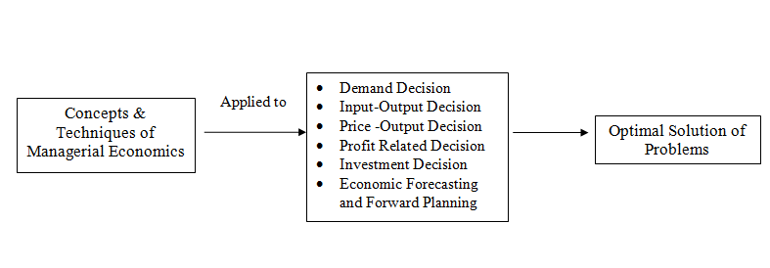

# Profit -related Decisions:

Here we employ the techniques such as Break even analysis, cost reduction and cost control and ratio analysis to ascertain the level of profits.

We determine break-even point beyond which firm start getting profits.

In other words, if the firm produces less than break- even point, it loses.

We can also plan the production needed to attain a given level of profits in short-run.

Cost reduction and cost control deal with the strategies to reduce the wastage and thereby reduce the costs.

These indirectly enhance the level of profits.

Ratio analysis helps to determine the liquidity, solvency, profitability of the activities of the firm.

There are certain ratios used to analyse and interpret the profitability of the firm given a set of accounting data.

# Investment Decisions

Investment decisions are also called capital budgeting decisions.

These involve commitment of large funds, which determine the fate of the firm. These decisions are irreversible.

Hence the manager needs to be more attentive while committing his scarce funds, which have alternative uses.

The allocation and utilisation of investments is paramount importance.

Capital has a cost. It is expensive. Hence, it is to be utilised in such a way as to maximise the return on capital invested.

It is necessary to study the cost of capital structure and investment projects before the funds are committed.

# Economic Forecasting and Forward Planning

Economic forecasting leads to forward planning.

The firm operates in an environment which is dominated by the external and internal factors.

The external factors include major forces such as government policy, competition, employment, labour, price and income levels and so on.

These influence its decision relating to production, human resources, finance and marketing.

The internal factors include its policies and procedures relating to finance, people, market and products.

It is necessary to forecast the trends in the economy to plan for the future in terms of investments, profits, products and markets. This will minimise the risk and uncertainty about the future.

**MANAGERIAL ECONOMICS RELATIONSHIP WITH OTHER DISCIPLINES:**

Many new subjects have evolved in recent years due to the interaction among basic disciplines. While there are many such new subjects in natural and social sciences, managerial economics can be taken as the best example of such a phenomenon among social sciences. Hence it is necessary to trace its roots and relationship with other disciplines.

**1. Relationship with economics:** The relationship between managerial economics and economics theory may be viewed form the point of view of the two approaches to the subject Viz. Micro Economics and Marco Economics. Microeconomics is the study of the economic behavior of individuals, firms and other such micro organizations. Managerial economics is rooted in Micro Economic theory. Managerial Economics makes use to several Micro Economic concepts such as marginal cost, marginal revenue, elasticity of demand as well as price theory and theories of market structure to name only a few. The relationship between managerial economics and economics theory is like that of engineering science to physics or of medicine to biology. Managerial economics has an applied bias and its wider scope lies in applying economic theory to solve real life problems of enterprises. Both managerial economics and economics deal with problems of scarcity and resource allocation.

**2. Management theory and accounting:** Managerial economics has been influenced by the developments in management theory and accounting techniques. Accounting refers to the recording of pecuniary transactions of the firm in certain books. A proper knowledge of accounting techniques is very essential for the success of the firm because profit maximization is the major objective of the firm. Managerial Economics requires a proper knowledge of cost and revenue information and their classification. A student of managerial economics should be familiar with the generation, interpretation and use of accounting data. The focus of accounting within the firm is fast changing from the concepts of store keeping to that if managerial decision making, this has resulted in a new specialized area of study called “Managerial Accounting”.

**3. Managerial Economics and mathematics:** The use of mathematics is significant for managerial economics in view of its profit maximization goal long with optional use of resources. The major problem of the firm is how to minimize cost, hoe to maximize profit or how to optimize sales. Mathematical concepts and techniques are widely used in economic logic to solve these problems. Also mathematical methods help to estimate and predict the economic factors for decision making and forward planning. Mathematical symbols are more convenient to handle and understand various concepts like incremental cost, elasticity of demand etc., Geometry, Algebra and calculus are the major branches of mathematics which are of use in managerial economics. The main concepts of mathematics like logarithms, and exponentials, vectors and determinants, input-output models etc., are widely used. Besides these usual tools, more advanced techniques designed in the recent years viz. linear programming, inventory models and game theory fine wide application in managerial economics.

**4. Managerial Economics and Statistics:** Managerial Economics needs the tools of statistics in more than one way. A successful businessman must correctly estimate the demand for his product. He should be able to analyses the impact of variations in tastes. Fashion and changes in income on demand only then he can adjust his output. Statistical methods provide and sure base for decision-making. Thus statistical tools are used in collecting data and analyzing them to help in the decision making process. Statistical tools like the theory of probability and forecasting techniques help the firm to predict the future course of events. Managerial Economics also make use of correlation and multiple regressions in related variables like price and demand to estimate the extent of dependence of one variable on the other. The theory of probability is very useful in problems involving uncertainty.

**5. Managerial Economics and Operations Research:** Taking effectives decisions is the major concern of both managerial economics and operations research. The development of techniques and concepts such as linear programming, inventory models and game theory is due to the development of this new subject of operations research in the postwar years. Operations research is concerned with the complex problems arising out of the management of men, machines, materials and money. Operation research provides a scientific model of the system and it helps managerial economists in the field of product development, material management, and inventory control, quality control, marketing and demand analysis. The varied tools of operations Research are helpful to managerial economists in decision making.

**6. Managerial Economics and the theory of Decision- making:** The Theory of decision-making is a new field of knowledge grown in the second half of this century. Most of the economic theories explain a single goal for the consumer i.e., Profit maximization for the firm. But the theory of decision-making is developed to explain multiplicity of goals and lot of uncertainty. As such this new branch of knowledge is useful to business firms, which have to take quick decision in the case of multiple goals. Viewed this way the theory of decision making is more practical and application oriented than the economic theories.

**7. Managerial Economics and Computer Science:** Computers have changes the way of the world functions and economic or business activity is no exception. Computers are used in data and accounts maintenance, inventory and stock controls and supply and demand predictions. What used to take days and months is done in a few minutes or hours by the computers. In fact computerization of business activities on a large scale has reduced the workload of managerial personnel. In most countries a basic knowledge of computer science, is a compulsory programme for managerial trainees. To conclude, managerial economics, which is an offshoot traditional economics, has gained strength to be a separate branch of knowledge. It strength lies in its ability to integrate ideas from various specialized subjects to gain a proper perspective for decision-making. A successful managerial economist must be a mathematician, a statistician and an economist. He must be also able to combine philosophic methods with historical methods to get the right perspective only then; he will be good at predictions. In short managerial practices with the help of other allied sciences.

## ****SIGNIFICANCE OF MANAGERIAL ECONOMICS****

1. **Business Planning** : Managerial economics assists business organizations in formulating plans and better decision making. It helps in analyzing the demand and forecasting future business activities.
2. **Cost Control**: [Controlling the cost](https://commercemates.com/objectives-of-cost-accounting/) is another important role played by managerial economics. It properly analyses and decides production activities and the cost associated with them. Managerial economics ensure that all resources are efficiently utilized which reduces the overall cost.
3. **Price Determination**: Setting the right price is one of the key decisions to be taken by every business organization. Managerial economics supplies all relevant data to managers for deciding the right prices for products.
4. **Business Prediction**: Managerial economics through the application of various economic tools and theories helps managers in predicting various future uncertainties. Timely detection of uncertainties helps in taking all possible steps to avoid them.
5. **Profit Planning And Control**: Managerial economics enables in planning and managing the profit of the business. It makes an accurate estimate of all cost and revenue which helps in earning the desired profit.
6. **Inventory Management**: Proper management of inventory is a must for ensuring the continuity of business activities. It helps in analyzing the demand and accordingly, production activities are performed. Managers can arrange and ensure that the proper quantity of inventory is always available within the business organization.
7. **Manages Capital**: Managerial economics helps in taking all decisions relating to the firm’s capital. It properly analyses investment avenues before investing any amount into it to ensure the profitability of an investment.

**ADVANTAGES OF MANAGERIAL ECONOMICS:**

Managerial Economics has become a highly useful and practical discipline now days as it helps to analyze and offers best s solutions to various kinds of problems faced in routine affairs of the organization in a systematic and realistic manner. The following points highlights significance of the managerial economics:

**1.** **Better allocation of resources:**

Managerial economics not only offers the better allocation of scarce resources among competing ends but also ensure the proper utilization of resources.

**2.** **Right decision at the right time:**

It helps the executives working in the firm to understand the various details of business and problems encountered and to take right decision at the right time by the identification of key variables in decision-making process. Thus managerial economics attempt to avoid the complexities of wrong decisions. Every manager has to take various relevant decisions about the utilization of limited resources like land, capital, labor, funds etc. to get the maximum returns, therefore, managerial economics, concentrates on practical aspects which facilitates decision-making.

**3.** **Identification of Problems:**

In today’s scenario economy is becoming highly competitive and dynamic, it helps in identifying various business and managerial problems, their causes and consequence, and suggests various policies and programs to overcome them.

**4. Offers tools and techniques:**

Managerial economics ensures availability of the various conceptual and technical skills, tools of analysis and techniques of judgment and other modern tools and instruments like elasticity of demand and supply, cost and revenue, income and expenditure, profit and volume of production etc to solve various dynamic problems of business.

**5. Attainment of business objectives:**

Managerial economics helps the business executives to become more responsive, realistic and competent to overcome upcoming challenges in the dynamic business scenario. This in turn facilitates achievement of various objectives like profit and wealth maximization, society welfare, Customer satisfaction, attaining industry leadership, market share expansion and social responsibilities etc.

**6. Facilitates decision making and forward planning:**

Managerial Economics enables decision making and forward planning by the evaluation of alternatives available to the managers.

**7. Understanding the various external factors:**

It also helps in understanding and analyzing the various external factors which affect the decision-making of an organization and ultimately affecting the functioning and the success of the firm.

**LIMITATIONS OF MANAGERIAL ECONOMICS**

Every coin has two sides, positive and negative. No doubt managerial economics provides sophisticated tools of analysis and facilitates the decision making initiated by the managers but on the other side it suffers from certain limitations. The various limitations are as follows:

* Managerial economics has led to the emergence of monopolies for the production of some important product and services. For example: electricity companies, Railways, Telephone companies. These companies exploit the consumers by charging high prices just to earn handsome profits.
* Another limitation of Managerial Economics seems from the emergence of Oligopoly in the market, where firms and producers formally collude with each other or enters into cartel agreement and charge higher price and restricts output.
* Small scale companies have to face high degree of competition due to the emergence of Multinational companies in or country, posing threat to the existence of the small firms. Small firms find it difficult to survive in the market.
* There seems to be great exploitation of worker, due to weak bargaining power of the workers. It is felt that women and child labour are offered very low wages for the work being taken from them.

**FUNCTIONS OF MANAGERIAL ECONOMIST**

The managerial economist is responsible for analysing the environment in which business operates. Proper study of all external factors that affect the functioning of organisation in must for proper functioning. He studies various factors like growth of national income, competition level, price trends, phase of the business cycle and economy and updates the management regarding it from time to time.

1. **Operations Analyses of business**

He analyses the internal operation of business and helps management in marketing better decisions in regards to internal workings. Managerial economist through his analytical and forecasting skills provides advice to managers for formulating policies regarding internal operations of the business.

1. **Demand forecasting and estimation**

Proper estimation and forecasting of future trends help the business in achieving desired profitability and growth. Managerial economist through proper study of all internal and external forces makes successful forecasting of future uncertainties or trends.

1. **Production planning**

Managerial economist is responsible for scheduling all production activities of business. He evaluates the capital budgets of organisations and accordingly helps in deciding timing and locating of various actions.

1. **Economic intelligence**

It provides economic intelligence services by communicating all economic information to management. Managerial economist keeps management always updated of all prevailing economic trends so that they can confidently talk in seminars and conferences.

1. **Performing investment analysis**

A managerial economist analysis various investment avenues and chooses the most appropriated one. He studies and discovers new possible fields of business for earning better returns.

FUNCTIONS OF MANAGERIAL ECONOMICS

• Studies the business environment

The managerial economics is responsible for analysing the environment

in which business operates. Proper study of all external factors that affect the

functioning of organisation in must for proper functioning. He studies various

factors like growth of national income, competition level, price trends, phase

of the business cycle and economy and updates the management regarding it

from time to time.

• Operations Analyses of business

He analyses the internal operation of business and helps management in

marketing better decisions in regards to internal workings. Managerial

economist through his analytical and forecasting skills provides advice to

managers for formulating policies regarding internal operations of the

business.

• Demand forecasting and estimation

Proper estimation and forecasting of future trends help the business in

achieving desired profitability and growth. Managerial economist through

proper study of all internal and external forces makes successful forecasting of

future uncertainties or trends.

• Production planning

Managerial economist is responsible for scheduling all production

activities of business. He evaluates the capital budgets of organisations and

accordingly helps in deciding timing and locating of various actions.

• Economic intelligence

It provides economic intelligence services by communicating all

economic information to management. Managerial economist keeps

management always updated of all prevailing economic trends so that they can

confidently talk in seminars and conferences.

• Performing investment analysis

A managerial economist analysis various investment avenues and

chooses the most appropriated one. He studies and discovers new possible

fields of business for earning better returns.

1. **Focuses on earning reasonable profit**

It assists management in earning a reasonable rate of profit on capital employed in the business. Managerial economist monitors activities of organisations to check whether all operations are running efficiently as per the plans and policies.

1. **Maintaining better relations**

A managerial economist maintains better relations with all internal and external individuals connected with the business. It is his duty to develop a peaceful and cooperative environment within the organisation and aims to reduce any oppositions talking place.

# DEMAND ANALYSIS

**INTRODUCTION OF DEMAND:**

Demand in common practice / ordinary language means the desire for an object. Suppose a person desires to have a car. It is called demand in ordinary usage.

But in economics demand has a separate meaning which is quite distinct from the above meaning.

A mere desire cannot become demand in Economics.

A desire which is backed up by (i) ability to buy and (ii) willingness to pay the price, is called demand. Unless the desire is accompanied by ability to buy and willingness to pay, it cannot be called demand in Economics.

# DEFINITIONS OF DEMAND

1. According to **Stonier and Hague,**

“ Demand in economics means demand backed up by enough money to pay for the goods demanded”.

This means that the demand becomes effective only if it is backed by purchasing power in addition to this there must be willingness to buy a commodity.

Thus demand in economics means the desire backed by the willingness to buy a commodity and the purchasing power to pay.

1. In the words of **Benham,**

“The demand for anything at a given price is the amount of it which will be bought per unit of time at that price ”. (Thus demand is always at a price for a definite quantity at a specified time.)

Thus demand has three essentials i.e., price, quantity and time. Without these three demand has no significance in economics.

# DETERMINANTS OF DEMAND

There are so many factors on which the demand for a commodity depends. These factors are Economic, Social as well as Political factors.

The affect of all these factors on the amount of demanded for the commodity is called Demand Function.

The following are some of the factors that cause a change in demand other than price factor.

# 1. Price of the Commodity:

The most important factor affecting on demand is the price of the commodity. The amount of the commodity demanded at a particular price is more popularly called price demand. The relation between price and demand is called the Law of Demand. It is not only the existing price but also expected changes in price, which affect demand.

# Prices of Related Goods

1. **Change** **in the prices of substitutes:**

In case of substitutes like tea and coffee an increase in price of one commodity leads to an increase in the demand for other commodity and vice versa. The rise in price of coffee shall raise the demand for tea.

# Change in the prices of complementary:

In case of complementariness a fall in price of one commodity leads to an increase in the demand for other commodity and vice versa. If the price of pens goes up, their demand is less as a result of which the demand for ink is also less. The price and demand go in opposite direction. The effect of changes in price a commodity on amounts demanded of related commodities is called cross demand.

# Income of the Consumer

The third most important factor influencing demand is consumer income. In fact we can establish a relationship between the consumer income and demand at different levels of income, price and other things remaining same. The demand for a normal commodity goes up and falls down when income rises and falls down.

But in case of Giffen goods the relationship is opposite. Demand always changes with a change in the incomes of the people. When income increases the demand for several commodities increases and vice versa.

# Tastes and Fashions of Consumers

The fourth most important factor influencing demand is consumers‟ tastes and fashions. The demand also depends on consumer's taste. Tastes include fashion, habit, customs etc.

A customer taste is also affected by advertisement. If the taste for a commodity goes up, its amount demanded is more even at the same price. This is called increase in demand. The opposite is called decrease in demand. A change in the tastes and fashions brings about a change in demand for a commodity. When commodity goes out of fashion, the demand for it will decrease even though the price remains the same. Demand curve shifts to the left.

# Advertisement:

Advertisement has become the most popular means in changing the demand for a commodity in the modern world. By a regular advertisement the preference of the consumers can be influenced.

# OTHER FACTORS

# Affect of Wealth

The amount demanded of the commodity is also affected by the amount of wealth as well as its distribution. When the wealth of the people is more, demand for the normal commodities is also more. If wealth is more equally distributed, the demand for necessaries and comforts is more. On the other hand, if some people are rich, while the majorities are poor, the demand for luxuries is generally higher.

# Change in Population

Increase in population increases demand for necessaries of life. The compositions of population also affect demand. Composition of population means the proportion of young and old and children as well as the ratio of men and women. A change in composition of population has an affect on the nature of demand for different commodities. A change in size as well as composition of population will affect the demand for certain commodities.

For example: An increase in size of population will increase the demand for food grains. Similarly, an increase in percentage of women increases the demand for bangles and sarees.

# Changes in Climate and Weather

Demand always changes with a change in weather or climate even though price remains unchanged. In summer the demand for cool drinks increases and in winter it decreases. The climate of an area and the weather prevailing there has a decisive effect on consumer‟s demand. In cold areas woolen cloth is demanded. During hot summer days, ice is very much in demand. On a rainy day , ice cream is not so much demanded.

# Changes in Government Policy

Government policy affects the demand for commodities through taxation. Taxing a commodity increases its price and demand goes down. Similarly, financial help from government increases the demand for a commodity while lowering its price.

# Expectations Regarding the Future

If consumers expect changes in price of commodity in future, they will change the demand at present even when the present price remains the same. Similarly, if consumers expect their incomes to rise in the near future they may increase the demand for a commodity just now.

# State of Business:

The level of demand for different commodities also depends upon the business conditions in the country. If the country is passing through boom conditions, there will be a marked increase in demand. On the other hand, the level of demand goes down during depression conditions.

# Technical Progress

Due to technical progress new commodities will enter into the market and demand for the old commodities will decrease. For example, Due to the introduction of electronic watches the demand for ordinary watches has decreased.

# DEMAND FUNCTION

Demand function is a mathematical expression of relation between the quantity demanded and its determinants. It can be expressed as follows

**QD = F( P, I, Psc, T, A)**

Where

Qd = quantity demand

F = functional relational between input

P = price of the product

I = income of the consumer

Psc= price of substituted or complementary

T = taste and preference

A = advertisement

**TYPES OF DEMAND**

Demand is generally classified on the basis of various factors, such as nature of a product, usage of a product, number of consumers of a product, and suppliers of a product.

The different types of demand are as follows:

**i. Individual and Market Demand:**

It refers to the classification of demand of a product based on the number of consumers in the market. Individual demand can be defined as a quantity demanded by an individual for a product at a particular price and within the specific period of time. Market demand is the aggregate of individual demands of all the consumers of a product over a period of time at a specific price, while other factors are constant.

**ii. Organization and Industry Demand:**

This refers to the classification of demand on the basis of market. The demand for the products of an organization at given price over a point of time is known as organization demand. The sum total of demand for products of all organizations in a particular industry is known as industry demand.

**Firm/Organization Demand:**

Firm demand, also known as individual or company demand, refers to the demand for a specific product or service from a single firm's perspective. It represents the quantity of a product that a particular firm's customers are willing and able to purchase at various prices. Firm demand is affected by factors such as the firm's marketing efforts, product quality, pricing strategies, and customer preferences. It is usually represented by a demand curve that shows the relationship between the price of the product and the quantity the firm is willing to produce and sell.

**Industry Demand:**

Industry demand, also known as market demand, refers to the total demand for a product or service across all firms operating in a particular industry. It represents the sum of the individual firm demands within that industry. Industry demand is influenced by broader factors such as overall economic conditions, population growth, consumer income levels, and trends in consumer preferences. The industry demand curve illustrates the relationship between the price of the product and the total quantity demanded by all consumers in the market.

In summary, the key difference between firm demand and industry demand lies in their scope of analysis. Firm demand focuses on the demand for a specific product or service from the perspective of an individual firm, while industry demand considers the overall demand for the same product or service across all firms operating within a particular industry. Both concepts are important in understanding market dynamics, pricing strategies, and the behavior of consumers and producers in a given market.

**iii. Demand for Perishable and Durable Goods:**

This refers to the classification of demand on the basis of usage of goods. The goods are divided into two categories, perishable goods and durable goods. Perishable or non-durable goods refer to the goods that have a single use. On the other hand, durable goods refer to goods that can be used repeatedly.

**iv. Short-term and Long-term Demand:**

This refers to the classification of demand on the basis of time period. Short-term demand refers to the demand for products that are used for a shorter duration of time or for current period. This demand depends on the current tastes and preferences of consumers. On the other hand, long-term demand refers to the demand for products over a longer period of time. Generally, durable goods have long-term demand.

**v. Autonomous and Derived Demand:**

This refers to the classification of demand on the basis of dependency on other products. The demand for a product that is not associated with the demand of other products is known as autonomous or direct demand. The autonomous demand arises due to the natural desire of an individual to consume the product. On the other hand, derived demand refers to the demand for a product that arises due to the demand for other products. Moreover, the demand for substitutes and complementary goods is also derived demand.

**Distinguish between Autonomous Demand and Derived Demand.**

|  |  |  |
| --- | --- | --- |
| **Characteristics** | **Autonomous Demand** | **Derived Demand** |
| Definition | "Autonomous demand" refers to the demand for a product or service that is not affected by or dependent on the demand for any other product or service. | The term "derived demand" describes the need for products and services shaped by the kind and scale of other endeavors. Induced demand is another name for derived demand. |
| Importance | Demand that is motivated by independent forces is more rigid. | Derived demand has a lower elasticity than derived demand. |
| Components | The autonomous demand is not specified. | Derived demand is distinguished by its precision. |

# LAW OF DEMAND

Law of demand states the relationship between price and quantity demanded. As per the law when price is increased demand will decrease, and similarly, when price is decrease demand will increase, this law assumed that, other things remaining constant, the change in price will inversely affect demand, thus the relationship between price and demand is inverse.

# A rise in the price of a commodity is followed by a fall in demand and a fall in price is followed by a rise in demand, if a condition of demand remains constant.

# DEFINITIONS OF LAW OF DEMAND

1. **ALFRED MARSHALL stated that Law of Demand as**

“A rise in the price of commodity or service is followed by a reduction in demand and fall in price is followed by an increase in demand, if the conditions of demand remain constant.”

Marshall stated that the Law of Demand basing on the law of Diminishing Marginal Utility..

1. **In the words of SAMUELSON**

The Law of Demand may be stated as “Other things being equal, the quantity demanded increases with a fall in price and decreases with a rise in price.”

# ASSUMPTIONS OF LAW OF DEMAND

Law of Demand is based on the following assumptions. The Law will hold good only if the following assumptions are fulfilled.

* 1. That the tastes and fashions of the people remain unchanged.
  2. That the people’s income remains unchanged / constant.
  3. That the prices of related goods remain unchanged / same.
  4. That there are no substitutes for the commodity in the market.
  5. That the people should not expect any change in the price of the commodity.

**DEMAND SCHEDULE**

# The Law of Demand may be explained with the help of the following Demand Schedule.

|  |  |
| --- | --- |
| **Price of Mangoes(Rs.)** | **Quantity Demanded** |
| 1 | 25 |
| 2 | 20 |
| 3 | 15 |
| 4 | 10 |
| 5 | 5 |

**DEMAND CURVE**

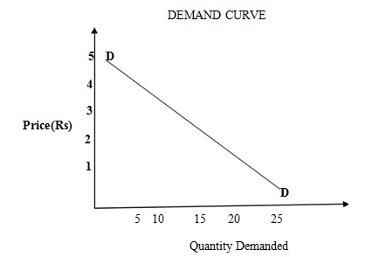

From the above table it is clear that as price of Mangoes rises from Rs.1 to Rs.2 demand falls from 25 to 20. When the price of Mangoes rises to Rs.5 quantity demand falls to 5 Mangoes. In the same way as price rises, quantity demand falls on the basis of demand schedule. We can draw a demand curve from the above Demand Schedule as follows. In the above Diagram, demand is shown on OX –axis and price is shown on OY-axis. DD is the demand curve. The demand curve DD shows the inverse relation between price and quantity demand of Mangoes. The demand curve slopes downward from left to right.

# EXCEPTIONS TO THE LAW OF DEMAND

Some times in case of some commodities demand curve slopes upwards from left to right.

It shows that when price rises demand also rises and when price falls demand also falls. In this case the demand curve has a positive slope.

We can draw the Exceptional Demand Curve as follows.

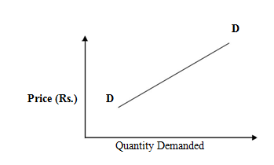

In the above Diagram, demand is shown on OX –axis and price is shown on OY-axis. DD is the demand curve. When price increases from OP to OP1 quantity demand also increases from OQ to OQ1 and the price falls down from OP1 to OP quantity demand also falls down from OQ1 to OQ.

Hence the exceptional demand curve slopes upwards from left to right in this diagram.

**The following are the important exceptions to the Law of Demand.**

* + 1. Giffen Paradox
    2. Prestige goods
    3. Speculation
    4. Trade Cycles
    5. Changes in Expectations.

# GIFFEN PARADOX

In the early part of the 19th Century, Sir Robbert Giffen, a British Economist observed that the Low paid British workers were purchasing more bread, when its price increased.

This is something contrary to the law of demand.

He observed that the people spend a major portion of their incomes on bread only a small part on meat.

Meat is more costly but less essential that bread.

When the price of the bread increased, they reduced the expenditure on meat.

With the money thus saved they purchased more bread to compensate for the loss of meat.

Thus where the price of bread is increases, its demand is also increased. This is the against law of demand.

This paradox was stated by Sir Robbert Giffen. Therefore, it is called Giffen Paradox.

Marshall could not explain this. It appeared to be a paradox to him.

The Demand Curve for Giffen goods(Inferior goods) goes upward from left to right as shown in the above diagram.

# PRESTIGE GOODS:

This exception is explained by Veblen. Costly goods like Diamonds, cars etc., are called prestige goods or as Veblen goods.

Generally rich people purchase those goods for the sake of prestige.

The use of such articles increases the prestige of owners.

So rich people may buy more of such goods when their prices rise.

Thus the amount demanded rises instead of falling, when the prices fall they do not purchase them because their value is reduced.

Therefore the demand decreases when the price falls.

This is against to the Law of Demand.

Since this exception is stated by Veblen, it is called Veblen effect.

# .3. SPECULATION:

When the price of a commodity rises and people expect that it will rise still further. Hence they buy more of that commodity.

Similarly, if they expect that there is going to be a further fall in the price, demand may not expand.

This is contrary to the Law of Demand.

# TRADE CYCLES:

During the periods of economic prosperity, people buy more even when the prices rise. This happens because the incomes of the people have gone up.

During times of depression, people buy less and less even when prices fall.

# CHANGES IN EXPECTATIONS:

When people expect a further rise in prices, people buy more when prices rise. They want avoid paying more in future.

Similarly, when people expect the prices to fall in further, they buy less and less as prices fall.

They may be expecting a further in prices.

**ELASTICITY OF DEMAND**

Elasticity of demand explains the relationship between a change in price and consequent change in amount demanded. “Marshall” introduced the concept of elasticity of demand. Elasticity of demand shows the extent of change in quantity demanded to a change in price.

In the words of “Marshall”, “The elasticity of demand in a market is great or small according as the amount demanded increases much or little for a given fall in the price and diminishes much or little for a given rise in Price”

**Elastic demand:** A small change in price may lead to a great change in quantity demanded. In this case, demand is elastic.

**In-elastic demand:** If a big change in price is followed by a small change in demanded then the demand in inelastic.

**Unitary Demand:** In which the fluctuation in one variable and quantity demand is equal.

# Types of Elasticity of Demand:

There are four types of elasticity of demand:

* 1. Price elasticity of demand
  2. Income elasticity of demand
  3. Cross elasticity of demand
  4. Advertising elasticity of demand

# Price elasticity of demand:

Elasticity of demand in general refers to price elasticity of demand. In other words, it refers to the quantity demanded of a commodity in response to a given change in price. Price elasticity is always negative which indicates that the customer tends to buy more with every fall in the price, the relationship between the price and the demand is inverse.

Proportionate change in the quantity demand of commodity

# Price elasticity =

Proportionate change in the price of commodity

Q2 - Q1/ Q1

EdP =

P2 – P1 /P1

Where:

Q1 = quantity demand before change

Q2 = quantity demand after change

P1 = price before change

P2 = price after change

# Measurement of Price Elasticity of Demand

1. Perfectly elasticity of demand
2. Perfectly inelasticity of demand
3. Relatively elasticity of demand
4. Relatively inelasticity of demand
5. Unity elasticity of demand

# 1. Perfectly elasticity of demand:

Perfectly elastic demand is when the [price](https://www.toppr.com/guides/business-economics/determination-of-prices/intro-to-determination-of-prices/) is constant but there is a change in the demand i.e. increase or decrease of a commodity. Thus, the demand curve is parallel to the X-axis.

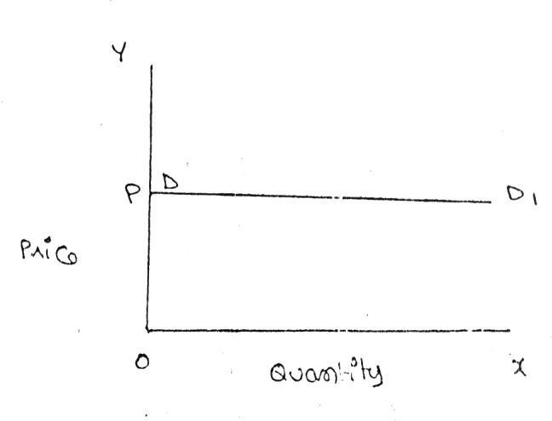

# 2. Perfectly inelasticity of demand:

When a significant degree of change in price leads little or no change in the quantity demanded, then the elasticity is said to be perfectly inelasticity. In other words, the demand is said to be perfectly inelasticity when there is no change in the quantity demanded even though there is a big change in the price.

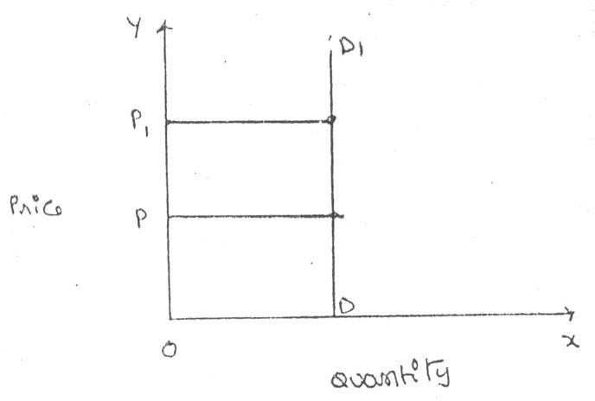

# 3. Relatively elasticity of demand:

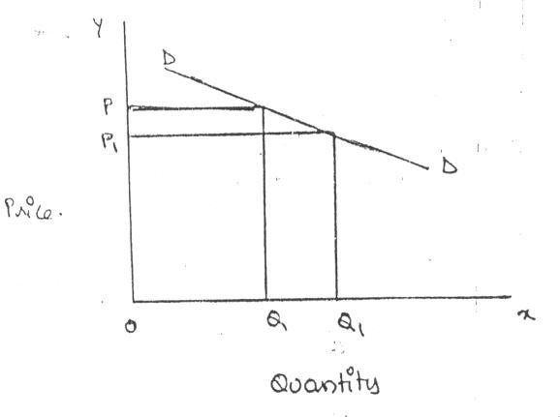The demand is said to be relatively elasticity when the change in demand is more than the change in the price.

# 4. Relatively inelasticity of demand:

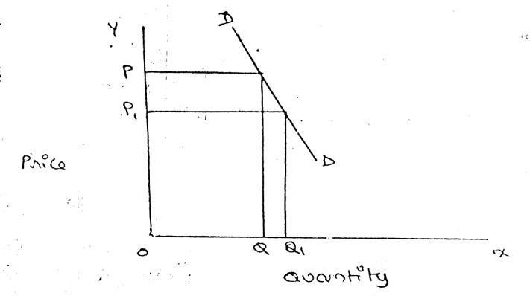The demand is said to be relatively inelasticity when the change in demand is less than the change in the price.

# 5. Unity elasticity:

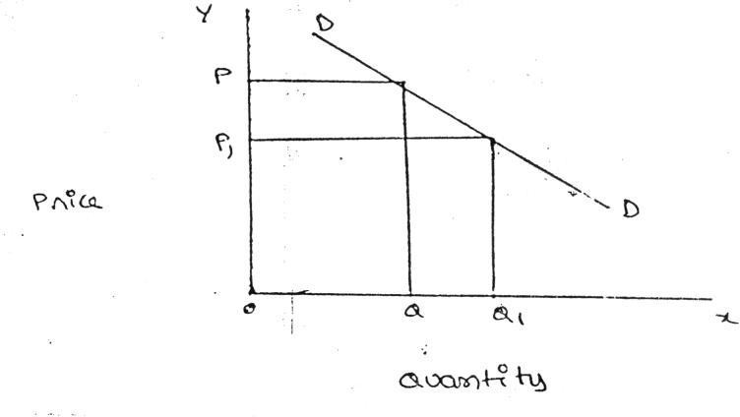The elasticity in demand is said to be unity when the change in demand is equal to the change in price.

# Income elasticity of demand:

Income elasticity of demand refers to the quantity demand of a commodity in response to a given change in income of the consumer.

Proportionate change in the quantity demand of commodity

# Income Elasticity =

Proportionate change in the income of the people

Q2 - Q1/ Q1

EdI =

I2 – I1 /I1

Where:

Q1 = quantity demand price before change

Q2 = quantity demand price after change

I1 = income before change

I2 = income after change

# Cross elasticity of demand:

Cross elasticity of demand refers to the quantity demanded of a commodity in response to a change in the price of a related good, which may be substitute or complement.

Proportionate change in the quantity demand of commodity “**X”**

**Cross elasticity** =

Proportionate change in the price of commodity “**Y”**

XQ2 - XQ1/ XQ1

EdC =

YP2 – YP1 /YP1

Where:

XQ1 = quantity demand price before change

X Q2 = quantity demand price after change

YP1 = price before change

YP2 = price after change

# Advertising elasticity of demand:

It refers to increase in the sales revenue because of change in the advertising expenditure. In other words, there is a direct relationship between the amount of money spent on advertising and its impact on sales. Advertising elasticity is always positive.

Proportionate change in the quantity demand of product “**X”**

**Advertising elasticity** =

Proportionate change in advertisement costs.

Q2 - Q1/ Q1

EdA =……………………….

A2 – A1 /A1

Where:

Q1 = quantity demand price before change

Q2 = quantity demand price after change

A1 = advertising before change

A2 = advertising after change

**FACTORS INFLUENCING THE ELASTICITY OF DEMAND**

Elasticity of demand depends on many factors.

**1. Nature of commodity:** Elasticity or in-elasticity of demand depends on the nature of the commodity i.e. whether a commodity is a necessity, comfort or luxury, normally; the demand for Necessaries like salt, rice etc is inelastic. On the other band, the demand for comforts and luxuries is elastic.

**2. Availability of substitutes:** Elasticity of demand depends on availability or non-availability of substitutes. In case of commodities, which have substitutes, demand is elastic, but in case of commodities, which have no substitutes, demand is in-elastic.

**3. Variety of uses:** If a commodity can be used for several purposes, than it will have elastic demand. i.e. electricity. On the other hand, demanded is inelastic for commodities, which can be put to only one use.

**4. Postponement of demand:** If the consumption of a commodity can be postponed, than it will have elastic demand. On the contrary, if the demand for a commodity cannot be postpones, than demand is

in-elastic. The demand for rice or medicine cannot be postponed, while the demand for Cycle or umbrella can be postponed.

**5. Amount of money spent:** Elasticity of demand depends on the amount of money spent on the commodity. If the consumer spends a smaller for example a consumer spends a little amount on salt and matchboxes. Even when price of salt or matchbox goes up, demanded will not fall. Therefore, demand is in case of clothing a consumer spends a large proportion of his income and an increase in price will reduce his demand for clothing. So the demand is elastic.

**6. Time:** Elasticity of demand varies with time. Generally, demand is inelastic during short period and elastic during the long period. Demand is inelastic during short period because the consumers do not have enough time to know about the change is price. Even if they are aware of the price change, they may not immediately switch over to a new commodity, as they are accustomed to the old commodity.

# SIGNIFICANCE OF ELASTICITY OF DEMAND

1. **Price of factors of production**:

The factors of production are land, labor, capital, organizations and technology. These have a cost; we have to pay rent, wages, interest, profits and price for these factors of production.

# Price fixation:

The manufacturer can decide the amount of price that can be fixed for his product based on the concept of elasticity, if there is no competition, in other words in the case of a monopoly, the manufacture is free to fix his price as long as it does not attract the attention of the government, when there are close substitutes, the product is such that its consumption can be postponed, it cannot be put to alternative uses and so on, then the price of the product cannot be fixed very highly.

# Government policies

* 1. **Tax policies**: government extensively depends on this concept to finalize its polices relating to taxes and revenues. Where the product is such that the people cannot postpone its consumptions, the government tends to increase its, price, such as petrol and diesel, cigarettes, and so on.
  2. **Raising bank deposits:** if the government wants to mobilize larger deposits from the consumer it proposes to raise the rates of fixed deposits marginally and vice versa.
  3. **Public utilities**: government uses the concept of elasticity in fixing charges for the public utilities such as elasticity tariff, water charges, ticket fare in case of road or rail transport .

# Forecasting demand:

Income elasticity is used to forecast demand for a particular product or services.

The demand for the products can be forecast at a give income level. The trader can estimate the quantity of goods to be sold at different income levels to realize the targeted revenue.

# Planning the levels of output and price:

The knowledge of price elasticity is very useful to producers. The producer can evaluate whether a change in price will bring in adequate revenue or not. In general, for items whose demand is elastic, it would benefit him to charge relatively low price. On the other hand, if the demand for the product is inelastic, a little higher price may be helpful to him to get huge profits without losing sales.

# DEMAND FORECASTING

Demand forecasting refers to an estimate of future demand for the product. It is an objective assessment of the future course of demand, in recent times, forecasting plays an important role in business decision – making. The survival and prosperity of a business firm depend on its ability to meet the consumer’s needs efficiently and adequately. Demand forecasting has an important influence on production planning. It is essential for a firm to produce the required quantities at the right time.

It is also essential to distinguish between forecasting of demand and forecast of sales, sales forecasts are important for estimating revenue, cash requirements and expenses whereas, demand forecasting relate to production, inventory control, timing, reliability of forecast etc. however, there is not much difference between these terms.

# METHODS OF DEMAND FORECASTING

1. Survey methods
2. Statistical methods
3. Other Methods
4. Expert opinion methods
5. Test marketing
6. Controlled experiments
7. Judgmental approach
8. **SURVEY METHODS**

The survey method of demand forecasting involves gathering data directly from consumers, customers, or market participants to make predictions about future demand for a product or service. This can be done through various means, such as telephone, online, focus groups, or in-person interviews. The data collected through surveys can provide valuable insights into consumers' opinions, attitudes, and buying behavior, which can be used to make informed predictions about future demand. The forecast's accuracy will depend on the size and representativeness of the sample, the quality of the survey questions, and the ability to generalize the findings to the larger population.

1. **Survey of consumer’s intentions:** In this method, information will be obtained by asking consumers about their buying intentions. This is direct method of estimating demand of consumers as to what they intend to buy today or in upcoming future. Almost every business organization makes survey on the choice or habits of its buyers’ either online or in other modes.

* Census Method
* Sample Method

1. **Survey of Sales force:** According to this method salesmen estimate sales in their respective geographical areas. The total estimated sales will be obtained by consolidating the estimations of various salesmen. These estimates are revised from time to time with respect to the factors affecting demand, like purchasing power, sales price etc.

# STATISTICAL METHODS

Statistical method is used for **long run** forecasting. In this method, statistical and mathematical techniques are used to forecast demand. This relies on **past data**.

1. **Trend projection method:** these are generally based on analysis of past sales patterns. These methods dispense with the need for costly market research because the necessary information is often already available in company files. This method is used in case the sales data of the firm under consideration relate to different time periods, i.e., it is a **time – series data**.

There are five main techniques of mechanical extrapolation.

1. **Trend line by observation:** this method of forecasting trend is elementary, easy and quick. It involves merely the plotting of actual sales data on a chart and them estimating just by observation where the trend line lies. The line can be extended towards a future period and corresponding sales forecast is read form the graph.
2. **Least squares methods:** this technique uses statistical formulae to find the trend line which best fits the available data. The trend line is the estimating equation, which can be used for forecasting demand by extrapolating the line for future and reading the corresponding values of sales on the graph.
3. **Time series analysis:** where the surveys or market tests are costly and time – consuming, statistical and mathematical analysis of past sales data offers another methods to prepare the forecasts, that is, time series analysis.
4. **Moving average method:** this method considers that the average of past events determine the future events. In other words, this method provides consistent results when the past events are consistent and unaffected by wide changes.
5. **Exponential smoothing:** this is a more popular technique used for short run forecasts. This method is an improvement over moving averages method, unlike in moving averages method, all time periods here are given varying weight, that is , value of the given variable in the recent times are given higher weight and the values of the given variable in the distant past are given relatively lower weights for further processing.
6. **Barometric Technique:** Simple trend projections are not capable of forecasting turning paints. Under Barometric method, present events are used to predict the directions of change in future. This is done with the help of economics and statistical indicators. Those are (1) Construction Contracts awarded for building materials (2) Personal income (3) Agricultural Income. (4) Employment (5) Gross national income (6) Industrial Production (7) Bank Deposits etc.
7. **Simultaneous equation method:** in this method, all variable are simultaneously considered, with the conviction that every variable influence the other variables in an economic environment. Hence, the set of equations equal the number of dependent variable which is also called endogenous variables.
8. **Correlation and regression methods:** correlation and regression methods are statistical techniques. Correlation describes the degree of association between two variable such as

sales and advertisement expenditure. When the two variable tend to change together, then they are said to be correlated

# OTHER METHODS

# Expert opinion methods:

Well informed persons are called experts; experts constitute yet another source of information. These persons are generally the outside experts and they do not have any vested interest in the results of a particular survey. As expert is good at forecasting and analysis the future trend in a give product or service at a given level of technology. The service of an expert could be advantageously used when a firm uses general economic forecasting or special industry fore casting prepared outside the firm.

# Test marketing:

It is likely that opinions given by buyers, salesman or other experts may be, at times, misleading. This is the reason why most of the manufactures favour to test their product or service in a limited market as test – run before they launch their product nationwide.

# Controlled experiments:

Controlled experiment refer to such exercise where some of the major determinants of demand are manipulated to suit to the customers with different tastes and preferences, income groups, and such others, it is further assumed that all other factors remain the same.

# Judgmental approach:

When none of the above methods are directly related to the given product or service, the management has no alternative other than using its own judgment. Even when the above methods are used, the forecasting process is supplemented with the factor of judgment for the following reasons

* Historical data for significantly long period is not available
* Turning point in terms of policies or procedures or causal factors cannot be precisely determined
* Sale fluctuations are wide and significant
* The sophisticated statistical techniques such as regression and so on, may not cover all the signing.

**DEMAND FORECASTING METHODS**

**SURVEY METHODS**

**STATISTICAL METHODS**

**OTHER METHODS**

Expert Opinion Methods

Test Marketing

Controlled Experiments

Judgmental Approach

1. Trend Projection Method

**Survey of Buyer’s Intention**

**Survey of Sales Forces**

1. Trend line by observation
2. Least square method
3. Time series analysis
4. Moving averages method
5. Exponential smoothing

2. Barometric Techniques

3. Simultaneous Equations Method

**Census Method**

**Sample Method**

4. Correlation and Regression

**Factors Governing Demand Forecasting**

1. **Functional nature of demand:** market demand for a particular product or service is not a single number but it is a function of a number of factors, for instance, higher volumes of sales can be realized with higher levels of advertising or promotion efforts.
2. **Types of forecasting:** based on the period under forecast, the demand forecast can be of two types

1) short – run forecasting and 2) long – run forecasting. Short run forecasts cover a period of one year whereas long- run forecasting any period ranging from one year to 20 years.

1. **Forecasting level**: the forecasting, are at the firm level, industry level, national level or at the global level.
2. **Firm level:** firm level means estimating the demand for the products and services offered by a single firm
3. **Industry level:** the aggregate demand estimated for the good and service of all the firms constitutes the industry level forecast. The total estimate of different trade associations can also be view as industry level forecast.
4. **National level :** national level forecasting is for the whole economy, national level forecasts are worked out based on the levels of income, savings of the consumers.
5. **Global level:** globalization and deregulation , the entrepreneurs have started exploring the foreign markets for which the global level forecasts are utilized.
6. **New product:** it is relatively easy to forecast demand for established products or products which are currently in use. The new product in consideration can be analyzed as a substitute for some existing product. Assess the demand through a sampled or total survey of consumers‟ intentions over the new product features and price.
7. **Nature of good:** The goods are classified into producer goods, consumer goods, consumer durables and services. The patterns of forecasting in each of these differ.
8. **Degree of competition:** there may be a single trader or a few traders depending upon the nature of goods and services.